DNS: IN vi forward.interns

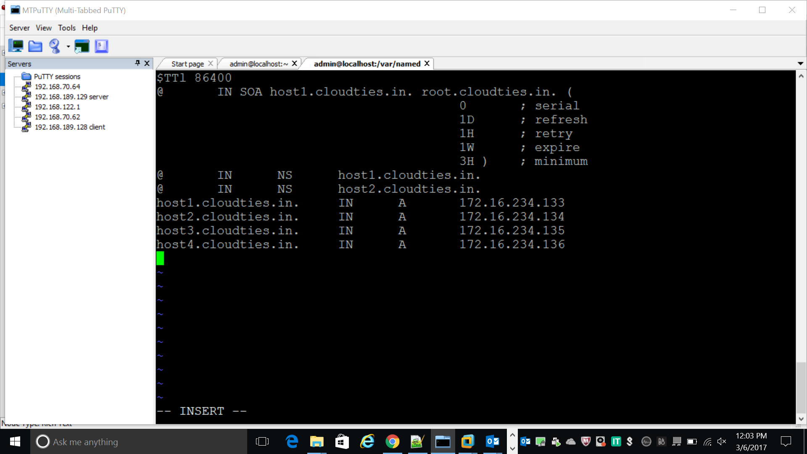

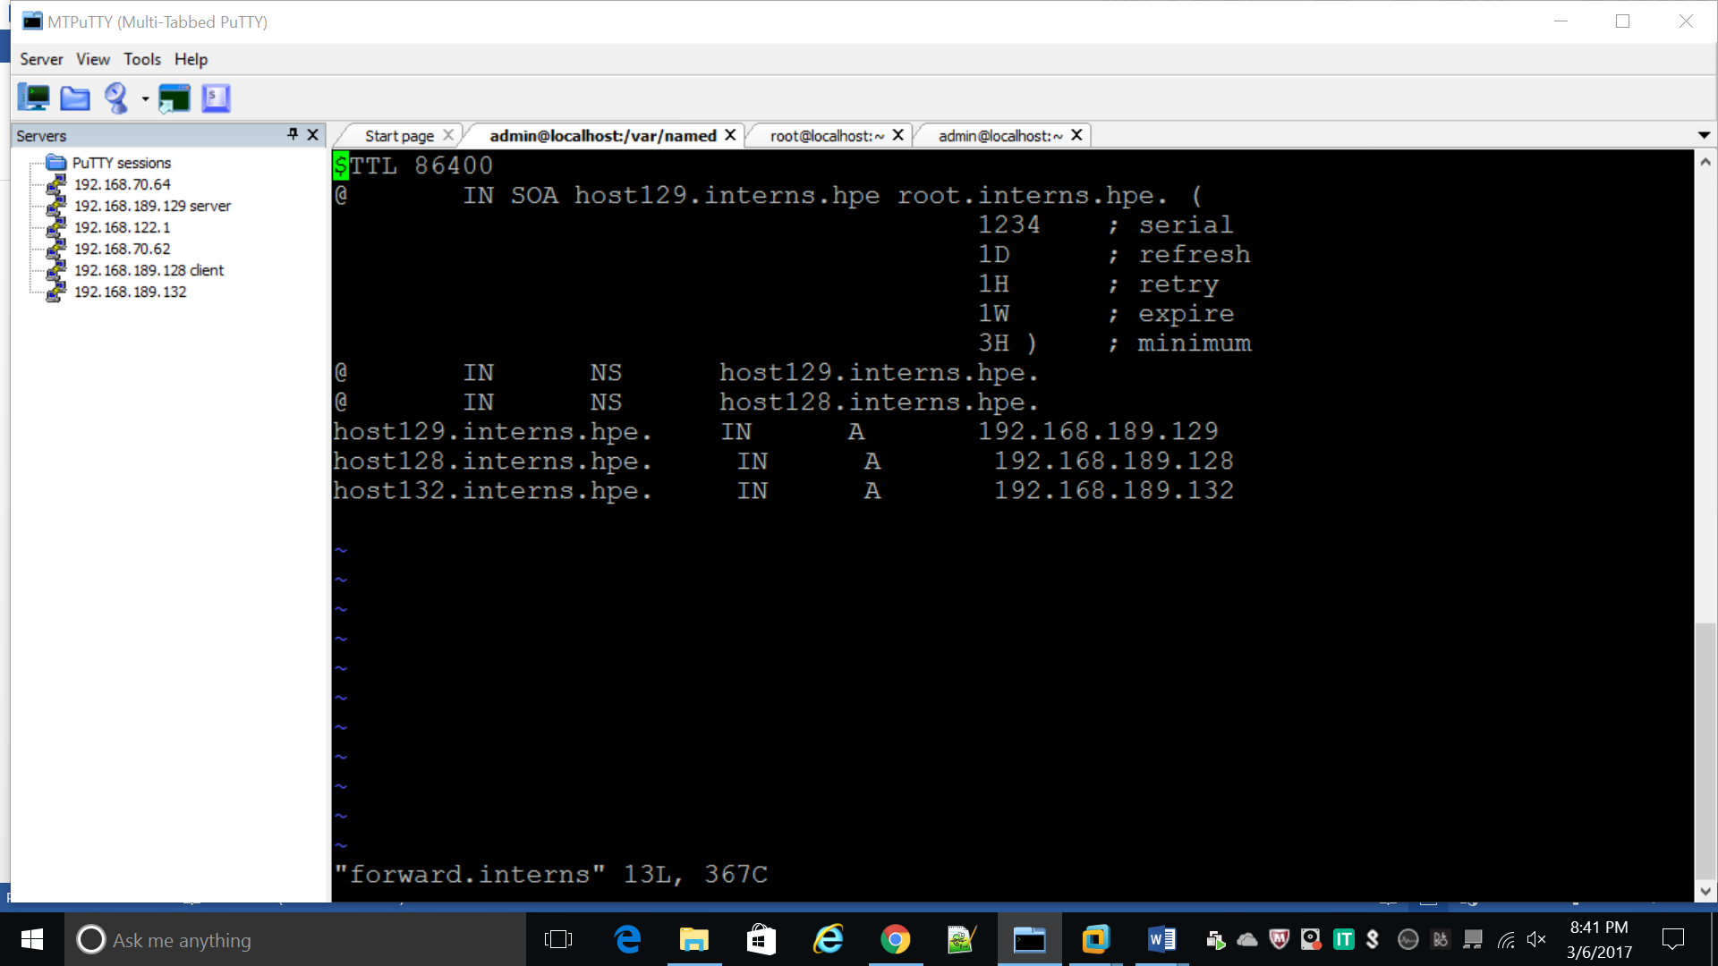

Vi forward.interns

$TTL 86400

@ IN SOA host129.interns.hpe root.interns.hpe. (

1234 ; serial

1D ; refresh

1H ; retry

1W ; expire

3H ) ; minimum

@ IN NS host129.interns.hpe.

@ IN NS host128.interns.hpe.

host129.interns.hpe. IN A 192.168.189.129

host128.interns.hpe. IN A 192.168.189.128

host132.interns.hpe. IN A 192.168.189.132

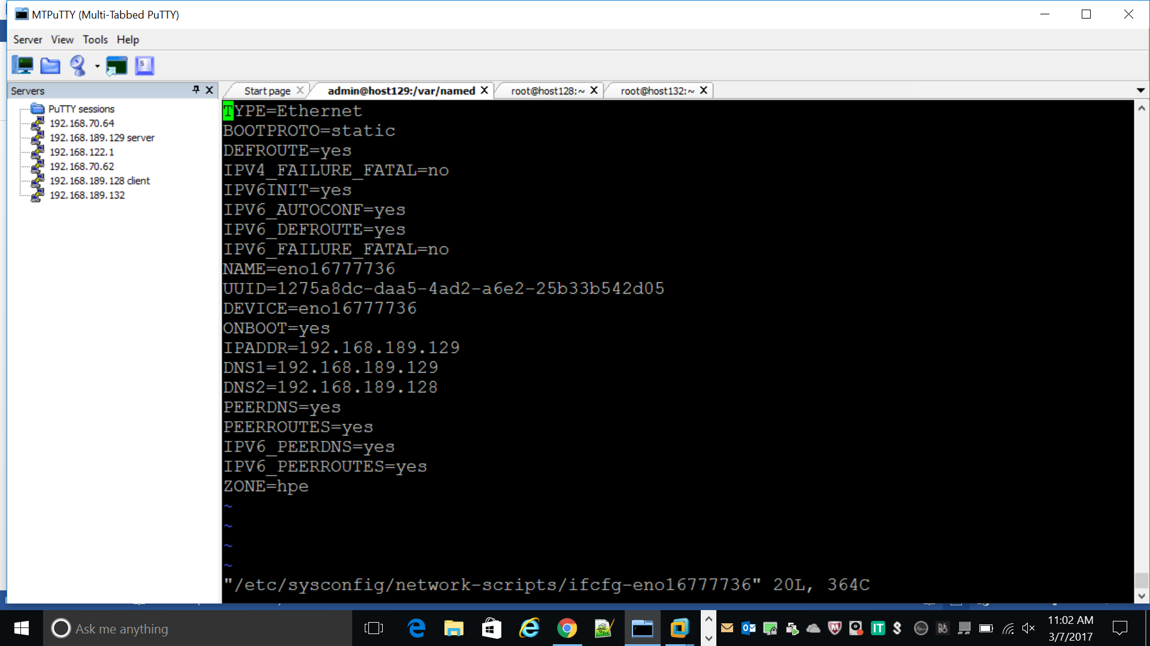

reverse

$TTL 86400

@ IN SOA host129.interns.hpe root.interns.hpe. (

1234 ; serial

1D ; refresh

1H ; retry

1W ; expire

3H ) ; minimum

@ IN NS host129.interns.hpe.

@ IN NS host128.interns.hpe.

host129.interns.hpe. IN A 192.168.189.129

host128.interns.hpe. IN A 192.168.189.128

host132.interns.hpe. IN A 192.168.189.132

129 IN PTR host129.interns.hpe

128 IN PTR host128.interns.hpe

132 IN PTR host132.interns.hpe

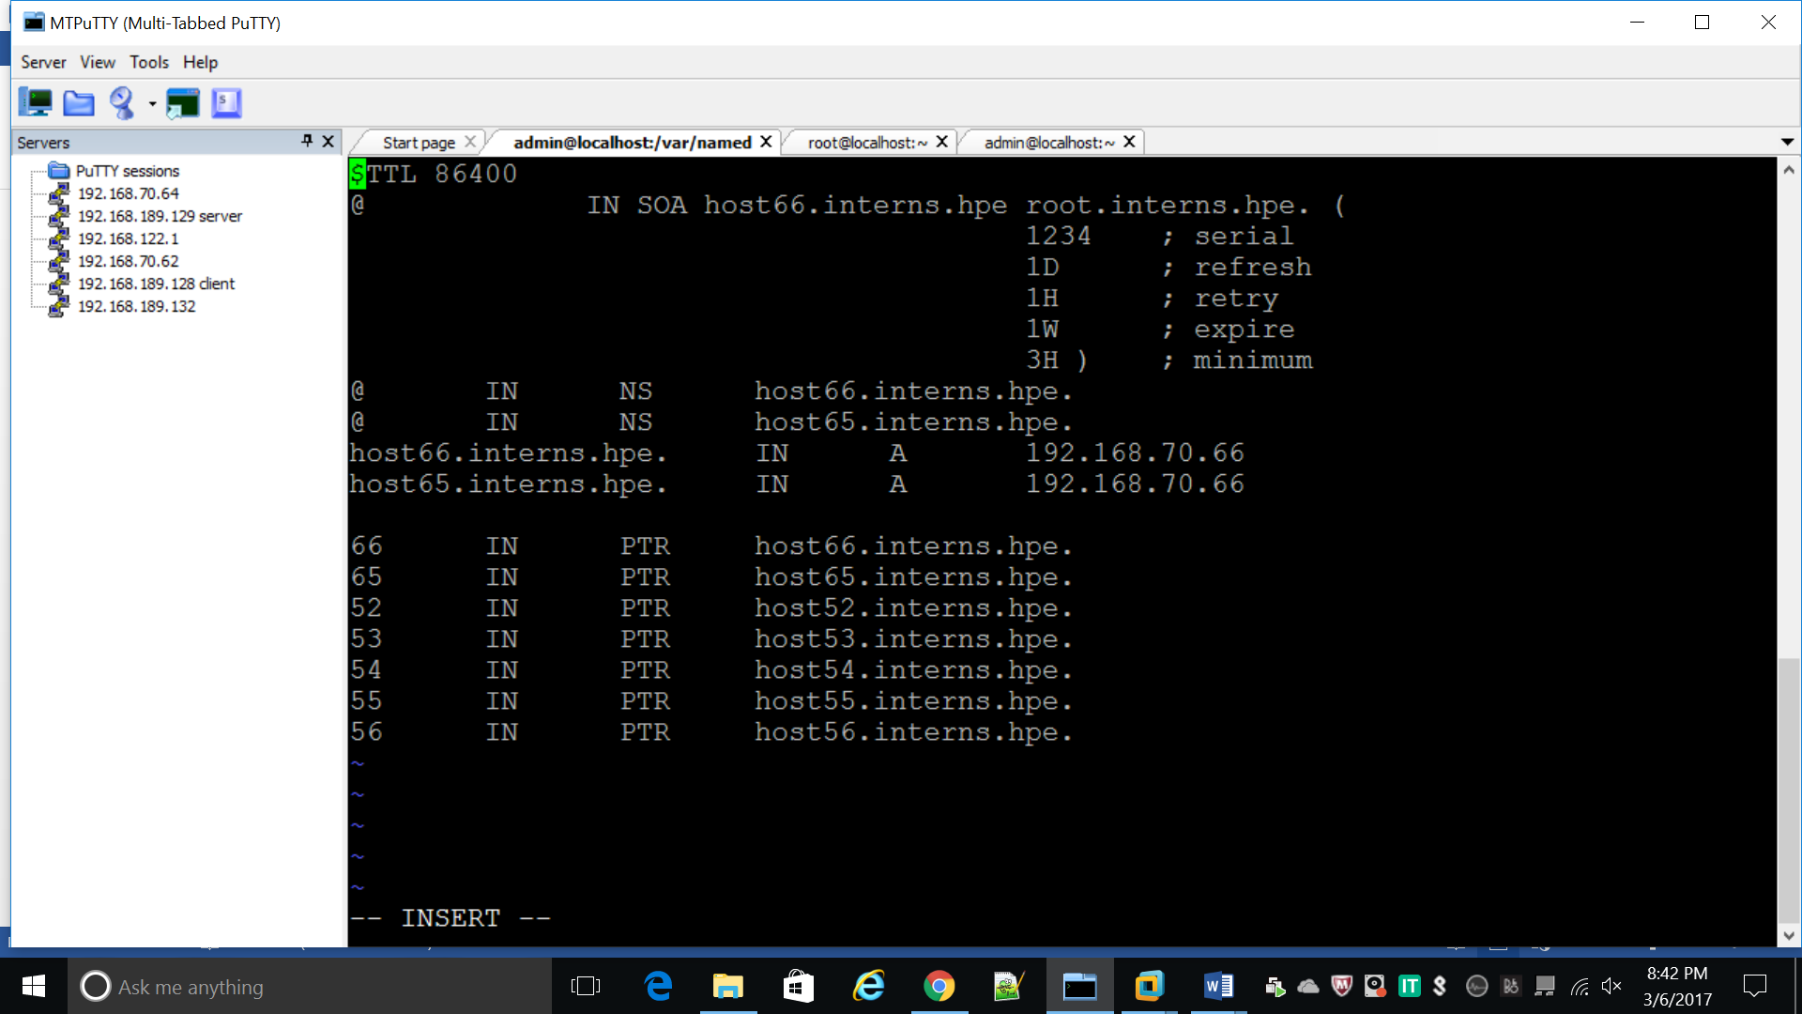

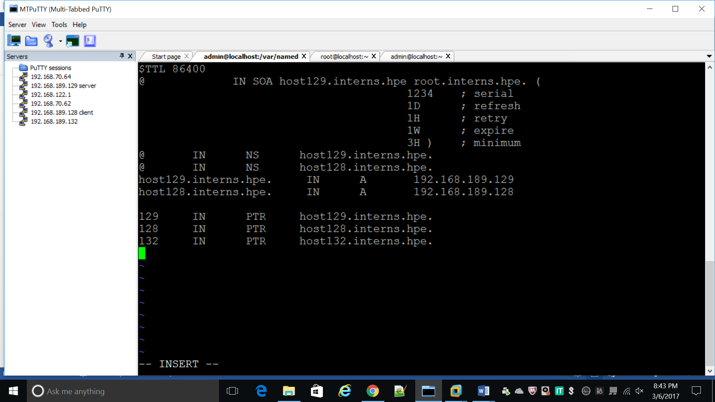

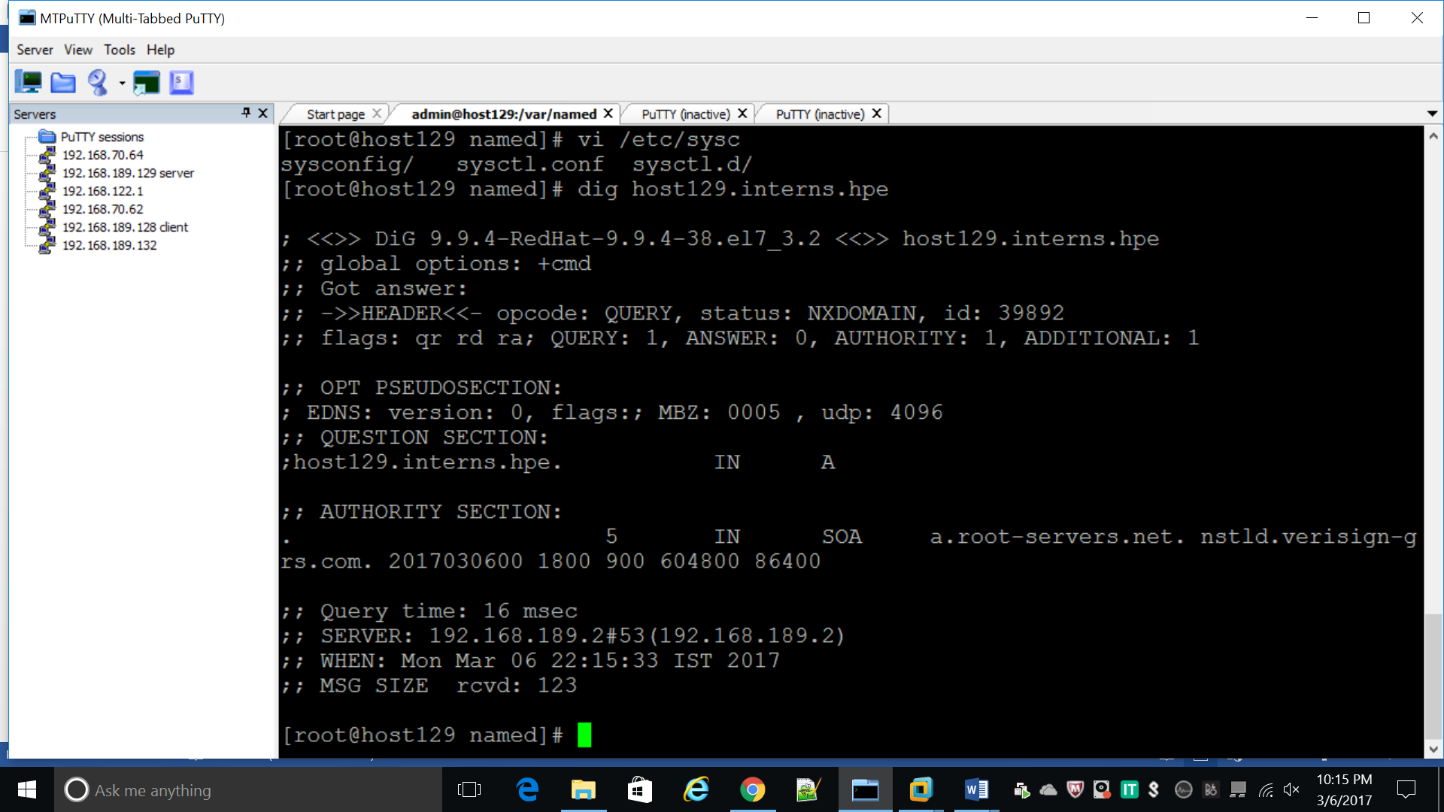

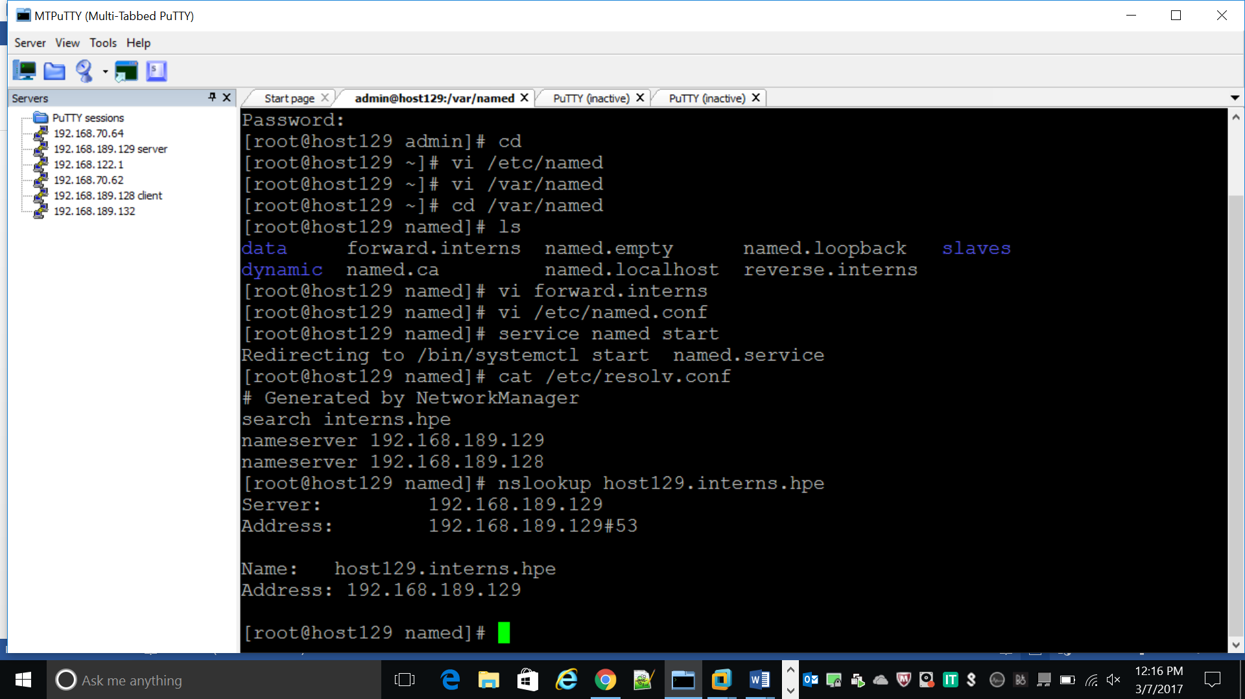

SLAVE:

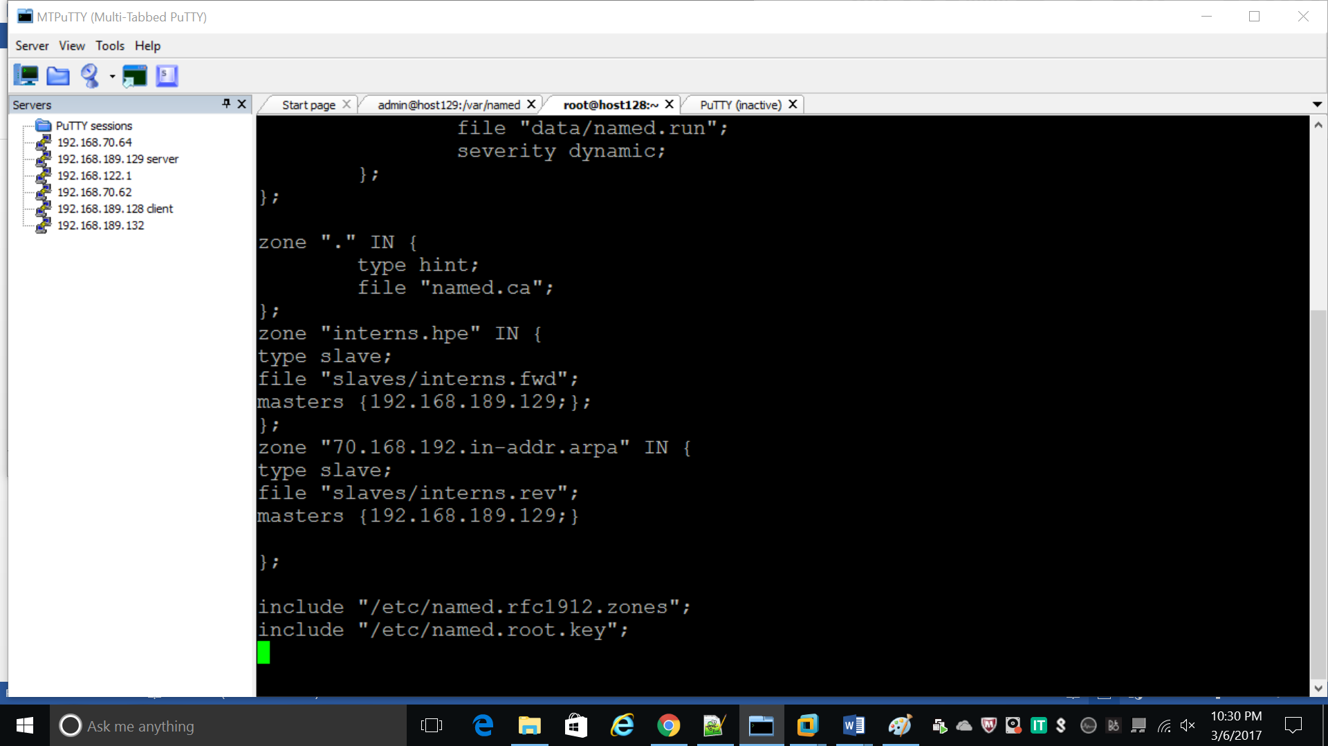

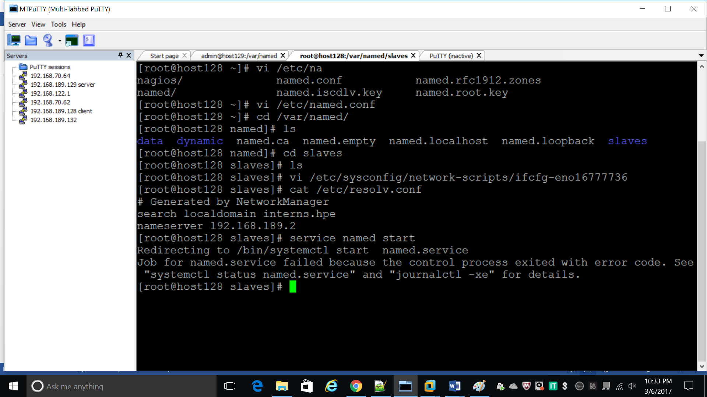

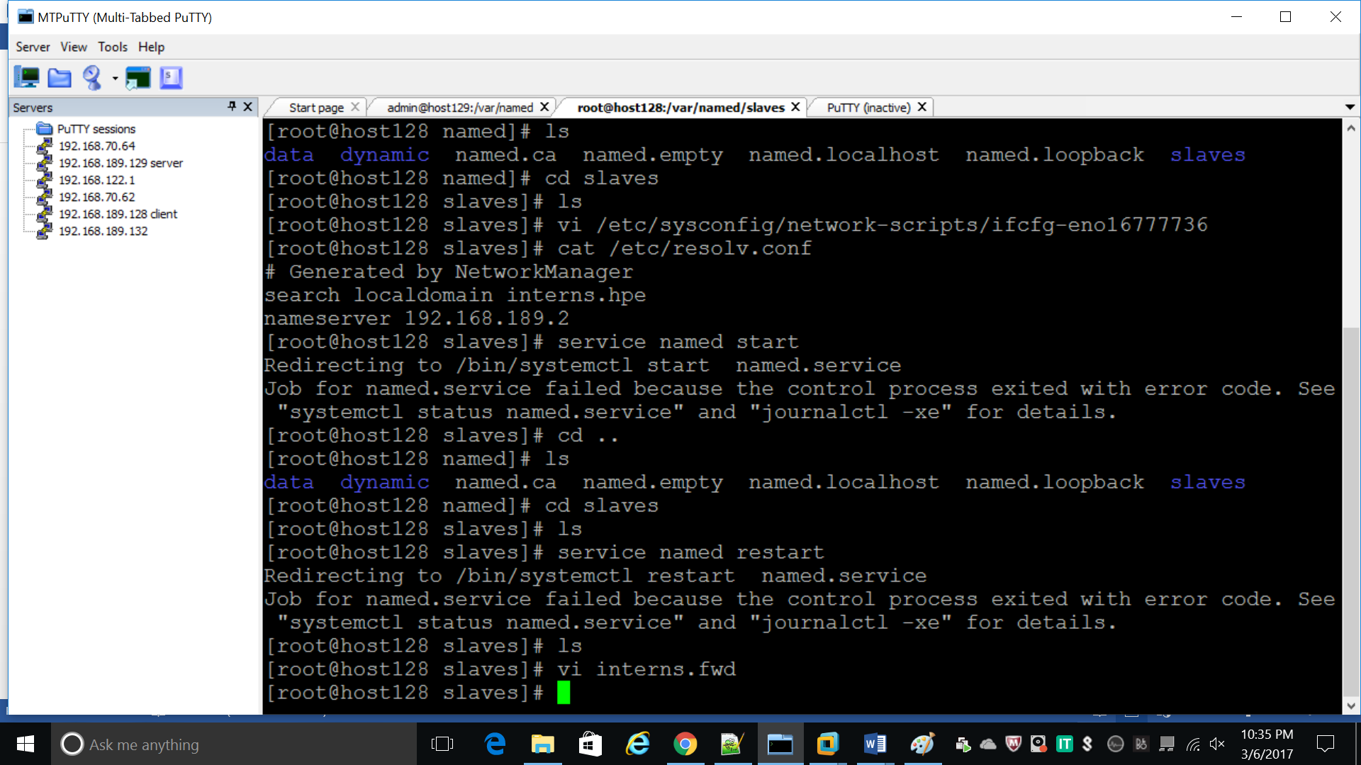

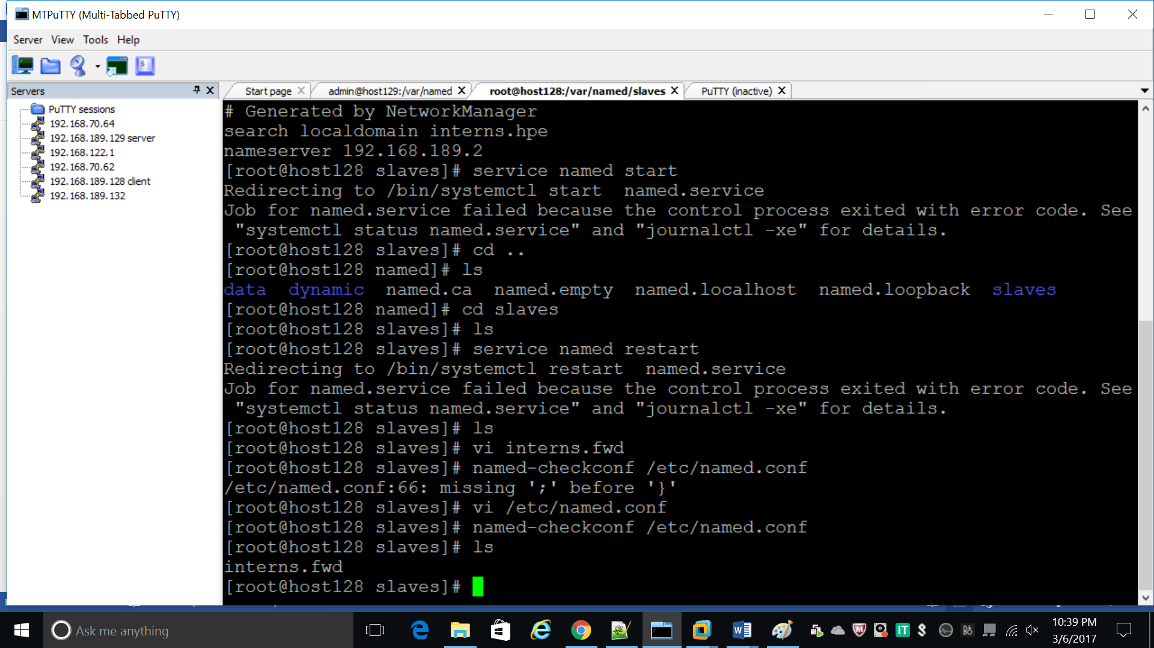

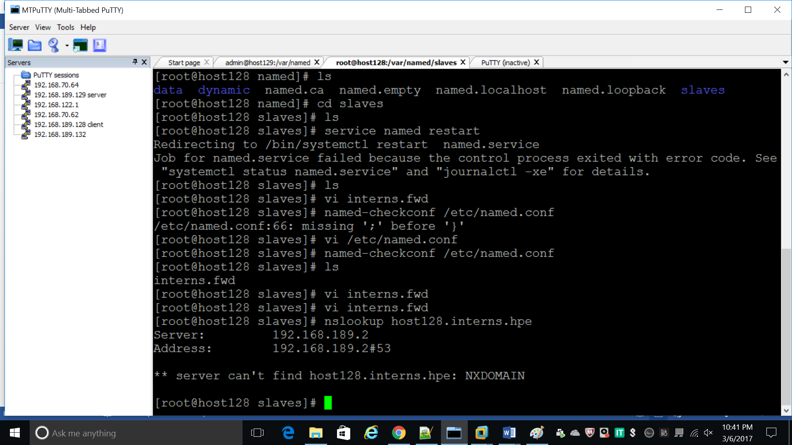

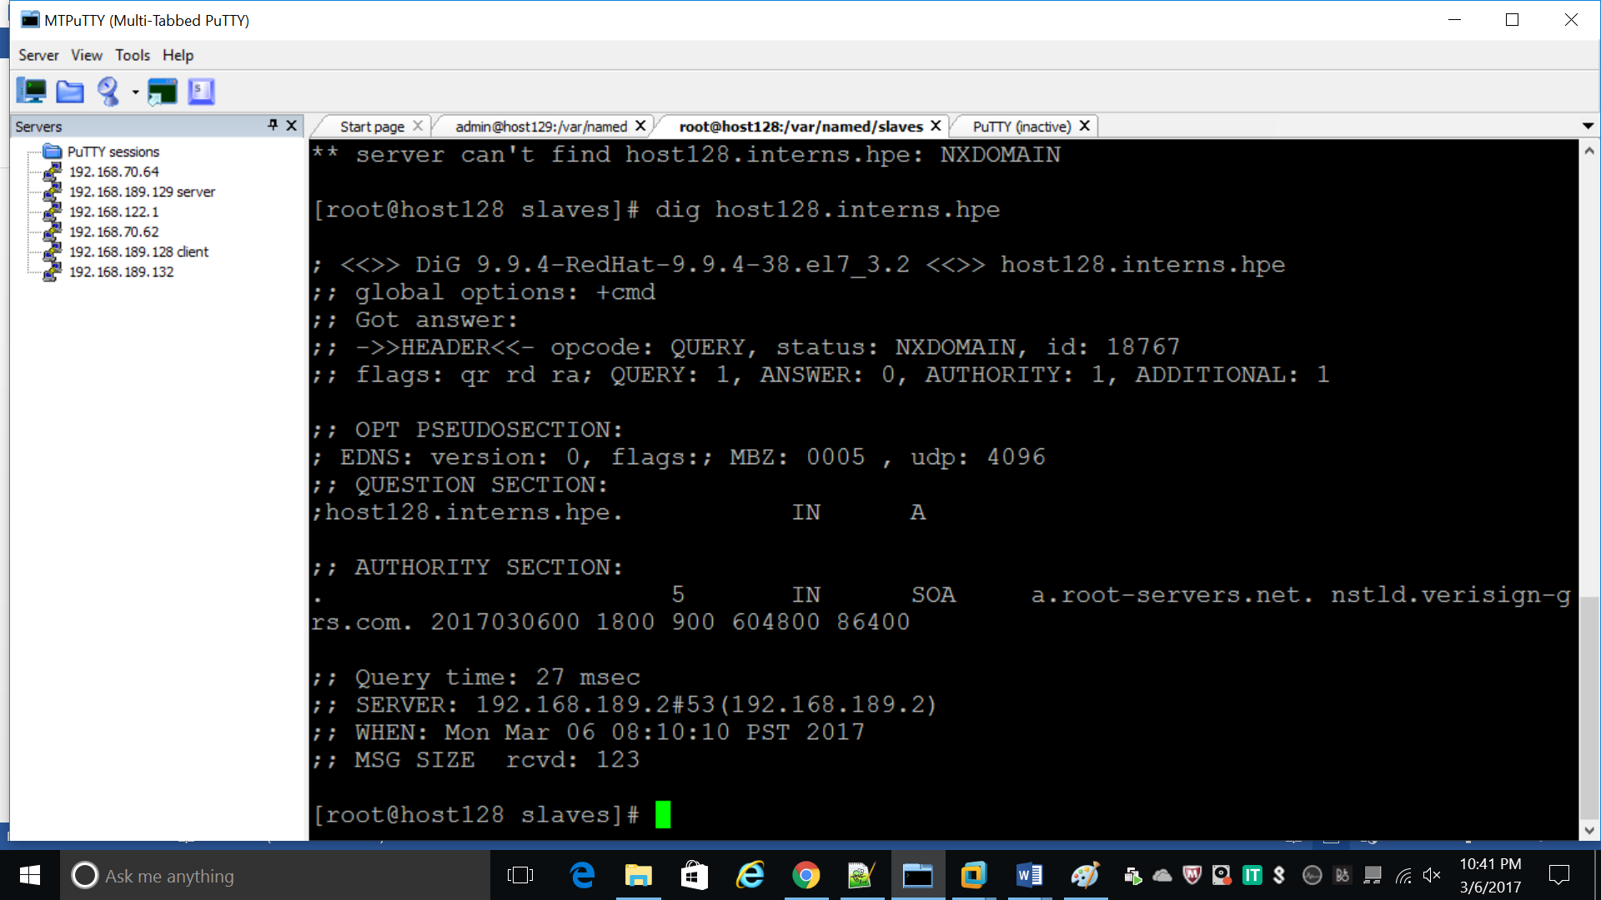

CLIENT:

